Topic 6.14: Hamiltonian Cycle Detection
Question
You are given an undirected graph represented by a list of edges and the number of vertices n. Your task is to determine if there exists a Hamiltonian cycle in the graph.
A Hamiltonian cycle is a cycle that visits each vertex exactly once and returns to the starting vertex.
Write a function that takes the list of edges and the number of vertices as input and returns true if there exists a Hamiltonian cycle in the graph, otherwise return false.
Aim
To design and implement an algorithm that determines whether a Hamiltonian cycle exists in an undirected graph.
Algorithm
- Represent the graph using an adjacency list.
- Start from vertex 0 and attempt to build a path covering all vertices.
- Use backtracking:
  - Mark the current vertex as visited and add it to the path.
  - Recurse into adjacent unvisited vertices.
  - If all vertices are visited and the last vertex connects back to the start, a Hamiltonian cycle exists.
- If no valid cycle is found after exploring all possibilities, return false.
Output
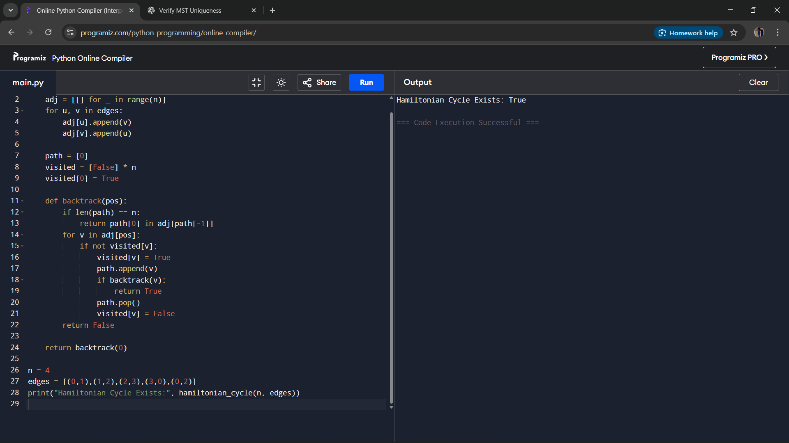
Result
The program successfully detects whether a Hamiltonian cycle exists in the given undirected graph and returns an example cycle when found.
Performance Analysis
- Time Complexity: O(n!) in the worst case, since all vertex permutations may need to be checked.
- Space Complexity: O(n) for path tracking and recursion stack.

